# Benchmark study for similar office building PPP projects

The main objective of the benchmark study is to identify performance gaps and opportunities for improving the efficiency and effectiveness of the construction of the office complex for Malawi Investment and Trade Center by prospecting similar projects, and to understand the business models used for their economic developments.

In this section, we will present an international benchmark study of relevant similar PPP projects for office buildings, namely:

* ICT Parks’ project in Egypt;
* Kuwait Post Office Project; and
* The Balard Hexagon project in France.

This benchmark study is based on documentary research as well as the consultant's experience in advising clients on different modes of PPP procurement for similar projects around the world.

## ICT Parks PPP Project, Egypt

### Project Presentation

The Ministry of Communications and Information Technology (MCIT) has dedicated 188 000 m² of land in Al Maadi to build an information and communications technology (ICT) cluster known as the CCC Park and was inaugurated in June 2010 by the General Authority for Investment (“GAFI”), the MoF and Cairo Governorate. Currently the Project has a total of 11 buildings, three of which are rented out to four multinational and local companies and are fully operational. Five buildings were inaugurated in June 2013.

To achieve the MCIT’s industry growth target, it plans to develop an additional 106 000m² of core and shell space. In order to attract ICT sector business into the park, the CCC Park planned to offer Grade "A" office space, built to international standards at remarkably affordable rents of US$ 11-16/ square meter/ month.

The CCC Park was established to provide a-state-of-the-art telecommunications infrastructure to emphasize Egypt as an ICT leader in the region, and one of the best outsourcing destinations in the world. It aims at mounting the exports of the Egyptian ICT services through national and international companies specialized in IT and outsourcing services. It was expected that the Park will host 40 thousand direct jobs in the next few years.

The Government kept encouraging foreign investors to come and construct their own buildings for outsourcing and offshoring to bet benefit from the modern infrastructure at the park providing cost effective ICT facilities using international standards of infrastructure.

Figure 2 The preliminary design of a Fully Integrated ICT Park

*Source: Minister of Communications and Information Technology*

### Project Structuration

The PPP aimed to finance, design, construct, furnish, operate and maintain administration buildings for usage or renting to the tenants working in the field of ICT specifically outsourcing and innovation on specific land lots located in Al Maadi Technology Park under a usufruct basis for a certain period.

Assets and buildings ownership shall be transferred back to the Ministry of Communications and Information Technology in good operational condition at the end of the contract duration as per stipulated in the contract.[1] The following figure summarizes the forecasted structure of the PPP project.

Figure 3 ICT Parks project forecasted structuration

*Source: Author*

The ICT Parks project was undertaken as a concession PPP. Within the concession, the private party is fully responsible of designing, building, financing, operating and maintaining the park, but also for bringing tenants to occupy the building and then share the revenue with the government.

As of today, three parks have been constructed and are fully operating; the first one is located in the City of the 6th of October, the second one in Al Maadi and the third one is in the East of Cairo.

The first park located in the 6th of October city (called the Smart Village) is considered to be the most successful project, hosting big multinational companies such as Vodafone, Dell, Xceed, etc, and managed by the Smart Villages Development and Management Company (SVC), a company established in November 2011 under the Public-Private-Partnership (PPP) investment law, developing and managing a branded chain of technology clusters and business parks.[2]

## Post office PPP Project, Kuwait

### Project presentation

The Partnerships Technical Bureau (“PTB”) has engaged a consortium of advisors to assist in procuring the services of a qualified and experienced investor or private sector operator (the “PSO”) who will develop and operate the Public Post Office (“PPO”) in the State of Kuwait.

Figure 4 Post offices' locations

*Source: Kuwait Post Office project’s Technical Advisor*

The Kuwait Post Project will provide the backbone for a major improvement to postal services in Kuwait. The proposed restructuring of the PPO will play a significant role in meeting the strategic and operational objectives of public postal services for Kuwait by revamping the entity’s existing product offering and improving operational efficiency and service quality. One of the Project’s initial challenges will be to restore consumer confidence in the current underperforming public sector entity; this will be to improve the financial performance of the PPO going forward.

### Project structuration

Corporatization of the PPO by setting up a new PPO Project Company, which would be a closed shareholding company owned by the Government of Kuwait. All assets, employees, rights, and responsibilities would be transferred into the new PPO Project Company, and this would be the new organisation for delivering postal services in Kuwait.

The new PPO Project Company would enter into a PPP agreement with a (PSO) to provide Operations and Management (O&M) services to the new PPO Project Company.

The ROT contract model was the most appropriate to improve performance and property management and refurbishment of the retail postal network.

Once the PSO has been appointed, it will establish a special purpose vehicle for the Project.

The PSO Company will be incorporated by the PSO as a limited liability company or a closed Kuwaiti shareholding company.

Unfortunately, the project stopped at phase II (feasibility study) and the Partnerships Technical Bureau never went through with the project.[3]

## The Balard Hexagon Building Project, France

### Project presentation

Historically, the Ministry of Defence was dispersed among several sites, in Paris and its suburbs (Îlot Saint-Germain, Hôtel de la Marine, Balard, Bagneux, Saint-Thomas d'Aquin, etc.).

To optimize the operation of the central administration and rationalize its land resources, the Ministry of Defense approved in December 2007 the proposal to bring together on a single site in Balard, its central administration, the staffs, directorates and services as well as the operational centers of the armies.

The Balard project is carried out under a public-private partnership (PPP) contract, integrating the architectural and technical design, the construction or renovation of buildings, their upkeep and maintenance. The contract also includes the construction and maintenance of computer and telephone networks.

The project is now complete. The public administration has completely moved in since September 2015. The building was officially inaugurated on November 5, 2015.

At the end of the contract, in 2041, the buildings of the entire site will be the property of the Ministry.[4]

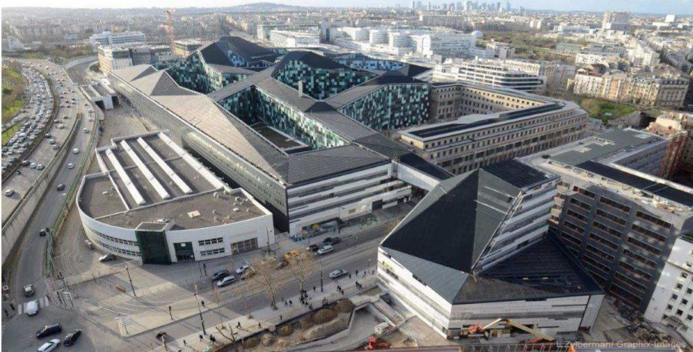

Figure 5 The Balard Hexagon

*Source: https://archicree.com/wp-content/*

### Project structuration

An SPV called “Opale Défense” (Group of signatory companies composed of Bouygues Construction, Bouygues Energie & Services, Thales Communication, Sodexo and FIDEPPP) was created to fund, design, build, operate and maintain (DBFOM) the project and sign a PPP contract with The Ministry of Defence.

The announced investment for carrying out the project is 3.5 billion euros excluding tax. The financing, carried by a group of companies dedicated to carrying out the project (Opale Défense), consists of:

* a contribution of equity and bank loans of approximately 785 million euros
* the payment of land rights for the occupation of the western horn for 30 years (approximately 220 million euros)
* direct payments from the ministry to finance the last instalment of work on the East plot, between 2014 and 2016 (approximately 75 million euros).

The average annual fee paid by the Ministry to Opale Défense will amount to 130 million euros excluding tax for 27 years, from the provision of the buildings (154 million euros including tax). It includes the amortization of the investment (35%) as well as the payments of other services:

* supply and maintenance of information and communication systems for 5 years
* the services provided for in the contract (catering in particular)
* the costs of maintenance and renovation of the works
* energy supply
* supply and maintenance of furniture for 10 years.

### Summary of the benchmark study, lessons learned and main recommendations

Local Urban Bodies/ Cities have been adopting the PPP model in various infrastructure projects to achieve one or more than one the following objectives:

* Augmenting Funds
* Superior Project Delivery
* Improve Efficiencies & Competitive Environment.

In most real estate and office buildings infrastructure projects, the PPP models used are the **DBFOM, BOT and ROT models**. The revenue stream in most cases comes from user payments (leasing fees, commercial activities, etc.) with a support from the government in the form of grants when needed. In other few cases (ex: the Balard hexagon project), the private party was receiving payments from the government for designing, building, financing, operating, and maintaining the project (government-pay model).

There is no doubt that these projects have faced difficulties, delays, performance gaps and in extreme cases project cancellation (ex: Kuwait Post Office Project). To avoid such problems going forward with the MITC Office Complex Project, a number of recommendations should be taken into consideration.

First, **minimizing future deviations** from financial, economic, and social projections with respect to project outcomes at the initial preparation stages is a key success factor. There must also be a safe and stable return on investment (ROI) model in place – one that is fair to both private and public partners.

Under the PPP model where projects are financed with user fees, almost all financial risk is transferred to the private-sector partner. This model works as long as user **projections are accurate**, however, it is not always possible to accurately predict demand. If usage projections are inaccurate, financial stress results quickly. Although public entities may suffer very little financial loss when calculations are incorrect, a governmental organization suffers in other ways if its partner is forced to find workaround strategies because user projections turn out to be wrong.

The government should also consider that similar projects make it hard to find contractors willing to take on any demand risk. For these reasons, it is preferable, in the event of sufficient financial resources, that the MITC office complex project is **structured around availability payments**. That means that once a project is completed and all specifications have been met, the public entity accepts the project and begins a payback model based on availability.

1. ICT Park PPP project’s pre-feasibility study and feasibility study reports
2. https://www.smart-villages.com/about-smart-village/
3. Kuwait Post Feasibility Study Report
4. [Édifice : Balard | Les Partenariats Public-Privé (psl.eu)](https://controverses.minesparis.psl.eu/public/promo15/promo15_G14/www.controverses-minesparistech-3.fr/_groupe14/exemples-emblematiques/balard/index.html)